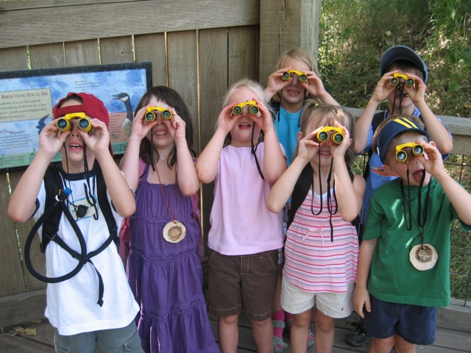
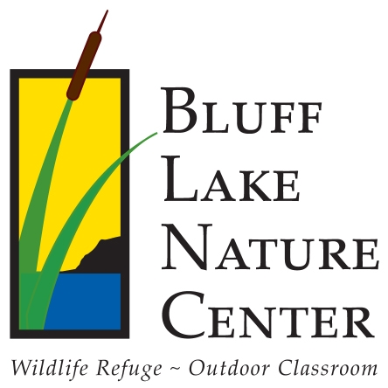
Earth Day 2012 at Bluff Lake Nature Center
CORPORATE SPONSORSHIP
Sponsorship Level | $100 | $250 | $500 | $1,000 | $2,500 | $5,000
Title sponsorship of Earth Day 2012 event and primary placement of logo in annual report and newsletter
Listing with logo as sponsor on Bluff Lake Nature Center’s corporate brochure
Original framed John Fielder Bluff Lake photograph with recognition plaque
Special announcement at Earth Day event recognizing donation
Corporate banner prominently displayed at Earth Day 2012 event
Inclusion on Earth Day 2012 event poster and program
Booth/table at Earth Day 2012 event
Corporate logo featured on Bluff Lake web site in conjunction with Earth Day 2012 event, and logo inclusion in annual report

Invitation for two to annual Bluff Lake Nature Center sponsor appreciation event
Sponsor recognition on the Bluff Lake Nature Center website, annual report, and monthly e-newsletter, and Bluff Lake Supporter decal
Bluff Lake Nature Center is remaking its annual Earth Day celebration into a family fun community event! Join us on Sunday, April 22: we anticipate at least 300 community members coming out to enjoy speakers, presentations, information booths, kids’ activities, and vendors. Please consider supporting our wildlife refuge and environmental education work, all while gaining recognition for your business or organizations! Supporting Bluff Lake is only natural!

